E-Fixed Deposits- A global bank to introduce a few feature

***Simplilearn Project for Capstone***

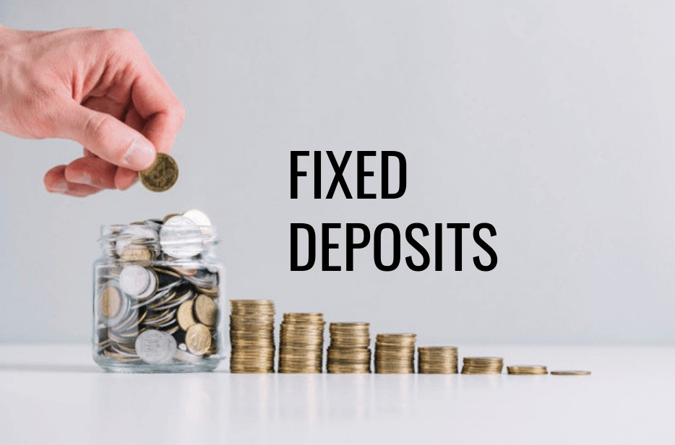

**Submitted by: Aiyappa kaiyandira Uthaiah**

Table of Contents

Project Tasks3

1. Project Overview4
2. As-is and Future Process Maps:6
3. Scope of Online FD, Main features to be developed7
4. In Scope & Out of Scope:8

In Scope8

Out of Scope8

1. Business requirements, functional and nonfunctional requirements9
2. Mock Screens of two features10
3. Product Backlog in JIRA: (Screenshot from JIRA)11

JIRA Board Screen shot15

JIRA EPIC Sample16

JIRA Sample user story16

1. Excel Tasks17
2. Tableau Tasks19

.19

## Project Tasks

|  |  |  |
| --- | --- | --- |
| **S No.** | **Tasks** | **References** |
| **1.** | Identifying Stakeholders – Create a list of stakeholders (as taught in Business Analysis Planning and Monitoring Knowledge Area) | Table 1: BACCM table  Figure 1: Stakeholder matrix and Onion Diagram |
| **2.** | Create As-Is and Future Process map (using flowcharts). | Figure 2: As-is Process  Figure 3: Future Process |
| **3.** | As a Business Analyst working on this project, find out the scope of online FD creation. Write down the main features that need to be developed | Table 3: Scope of Fixed Deposits and Features to be developed in the Project |
| **4.** | Write the in-scope and out-of-scope items for this software | Table 4: In Scope & Out of Scope requirements |
| **5.** | Write out the business requirements, both functional and nonfunctional requirements. | Section 5 |
| **6.** | Draw wireframes or mock screens for any two of the features. | Section 6 FD Creation and FD Calculator |
| **7.** | Make a product backlog of user stories for the given case study with acceptance criteria (JIRA) | Section 7 – Table with JIRA user story breakdown and screenshot of JIRA board |
| **8.** | Excel Tasks | Section 8: Screenshot and excel file attachment |
| **9.** | Tableau Task | Section 9 : Tableau Board screenshot |

# Project Overview:

Table 1: Captured below is the Project Objective using the **Business Analysis Core Concept Model (BACCM)**

|  |  |
| --- | --- |
| **Business Need**  **/ Problem Statement** | One of the leading banks across the globe, is ABC Bank. It has a presence in 56 countries in the world.  ABC Bank currently has a manual option to create fixed deposits. The bank users go to the nearest ABC Bank branch and create a fixed deposit. ABC Bank has a future vision of being a 100% online bank and wants to do away with all its manual banking processes. They have  identified the need to create e-fixed deposits |
| **Change** | ABC Bank currently wants to introduce this to their existing bank users with a future of introducing this feature to non-ABC Bank users |
| **Solution** | Provision of opening an FD online   * **Easy and less time-consuming**: An online FD can eliminate the process of visiting the bank physically and makes the process of creating an FD an extremely easy and hassle-free process. * **Easy payment:** Paying for the FD is extremely easy and can be done directly through net banking that makes the process of payment very convenient. All that is required is to transfer the money from the savings account to the respective FD account. * **Easy renewal and closure:** Once an FD account is opened online, it is possible to renew and close the deposit online instantly. Therefore, it eliminates the need of going to the bank for any of these purposes. |
| **Stakeholder** | *Figure 1: Stakeholder Map via Stakeholder Matrix and Onion Peel Diagram* |

|  |  |
| --- | --- |
|  | Goverement Regulators, Law & Finance Ministry  Investors, Domain SME's, Higher Management, IT operations  Bank Manager, Middle Office Managers, Front End IT support  Business Analyst, Implementation team, Tester,Project Manager |
| **Value / Objectives** | * Provision to create a fixed deposit using their existing online account * Provision to create a fixed deposit using their existing mobile account * Provision to create joint FD * Allows hassle free, easy, and less time-consuming process of creating a FD * Making payment to FD though online process making it more secure for the bank users * Easy Renew paperless process * Credit maturity amount to user’s savings or current account * Reduced time to generate daily reports as the process is automated and the records are generated real time |

# As-is and Future Process Maps:

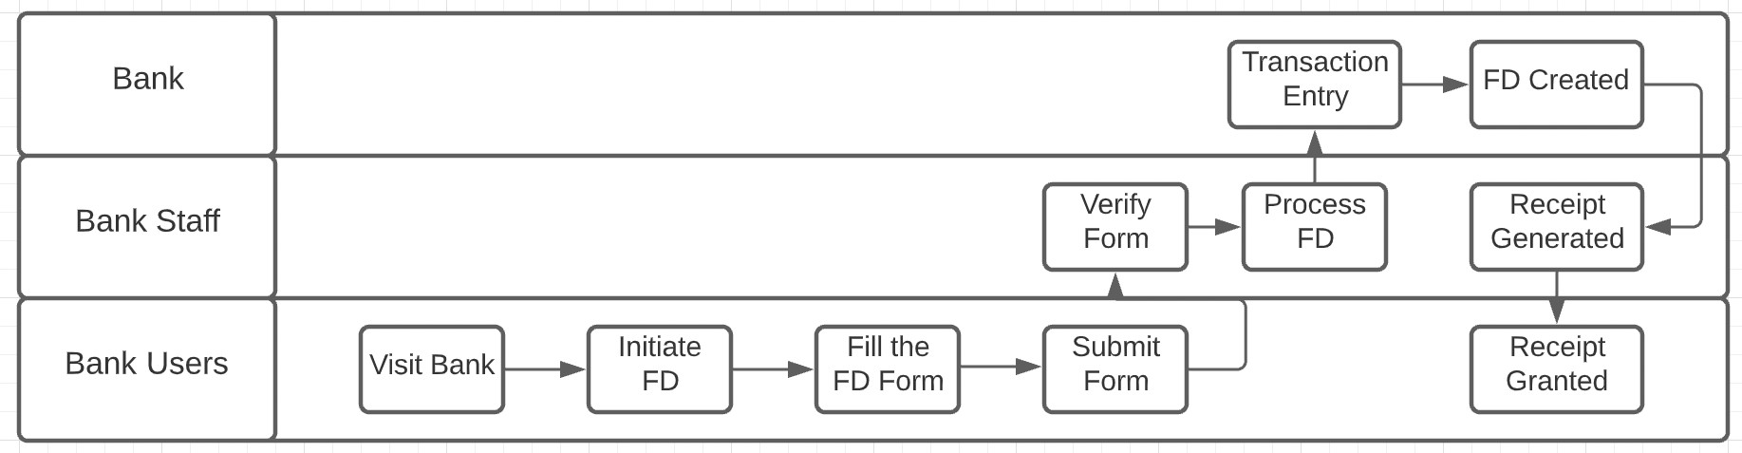

*Figure 2: As-is Process Map*

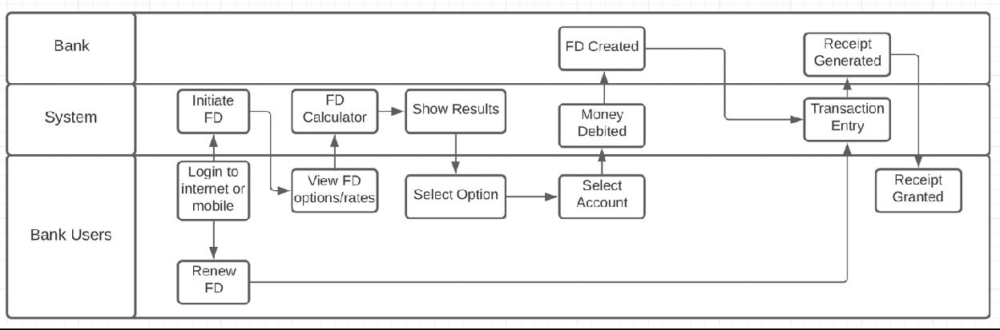

*Figure 3: Future Process Map*

# Scope of Online FD, Main features to be developed:

|  |  |
| --- | --- |
| **Scope** | A Fixed Deposit is a considered one of the safe investment instruments thought which you can earn interest income  Fixed Deposits promise guaranteed returns and involve no risk of loss of principal amount as they are not unaffected by market fluctuations  The scope of investment has expanded tremendously in recent times. Banks today offer multi-investment plans for you to choose from; one of them is Fixed Deposits. Fixed Deposits are the most secure method of investment. You earn guaranteed returns that are unaffected by market fluctuations.  Main Features of Fixed Deposit & Benefits   * Secure Investment - Fixed Deposits are safe instruments that offer fixed returns * No Risk - There is no risk in the principal amount invested * Rate of Interest - You can opt to receive the interest earned either periodically, i.e., monthly, or quarterly or go with the cumulative method and receive a lump sum amount on maturity. * Most banks offer senior citizens a 0.5% higher interest rate on Fixed Deposits. * Returns on Fixed Deposits are safe from market fluctuation. * You can also have the option to apply for a top-up loan against your Fixed Deposit in case you need funds. * Flexible Tenure and Renewal - FDs can be held for tenures lasting for a week to   10 years. You can choose your preferred term at the time of opening the FD, which can be conveniently renew the FD on maturity |
| **Main Features to be Developed** | 1. Provision to create a Fixed Deposit online through the web portal of the bank 2. Provision to create a Fixed Deposit online through the mobile application of the bank 3. Provision to select appropriate fixed deposit option based on tenure and interest rate for normal users 4. Provision to select appropriate fixed deposit option based on tenure and interest rate for senior citizen users 5. Provision to for user to calculate maturity amount using fixed deposit calculator by entering the amount the user the interested in investing and selecting the tenure 6. Provision to select the bank account from which the money should be deducted for the fixed deposit if the user more one account in ABC bank 7. Provision to Renew the fixed deposit with two maturity instructions 8. Provision to create joint fixed deposit case the name of the other customer along with his/her SSN details 9. Provision to add Nominee details to the fixed deposit |

|  |  |
| --- | --- |
|  | 1. Provision to fixed deposit receipt in PDF format which should be emailed to the customer as the information mentioned in the system 2. Provision to fixed deposit PDF copy to reflect in the online banking account and mobile banking account 3. Provision to generate reports in the system |

*Table 3: Scope of Fixed Deposits and Features to be developed in the Project*

# In Scope & Out of Scope:

|  |  |
| --- | --- |
| In Scope | Out of Scope |
| * Creation of Fixed Deposit for existing Internet banking and Mobile Banking user * System should check if the users creating fixed deposit meet the following criteria   + Have a savings account with ABC Bank   + Have an active online banking account   + Have an active mobile banking account * List of latest Fixed deposit rates by tenure, amount to be invest and user (Regular, Senior) should be displayed to the user depending on the user interface (Internet, Web) they are using * Fixed Deposit calculator should allow the user to calculate the maturity amount based on the input provided by the users * Account selection from which money should be debited to create fixed deposit * Option to renew the fixed deposit * Option to close the fixed deposit before maturity * Create Joint fixed deposit * Specify Nominee details * Reports | * Creation of Fixed Deposit for user who do not have account in ABC bank * Transfer of Fixed Deposits |

*Table 4: In Scope & Out of Scope requirements*

# Business requirements, functional and nonfunctional requirements

### Functional Requirements

* + 1. **Bank User (Mobile & Internet banking)**
       - As a customer of ABC I should be able to a create a fixed deposit using my online banking account or existing mobile banking account so that I can invest my money in it
       - As a customer of ABC I should be able to view the various FD rates based on period, amount to be invested and interest rates applicable for normal/senior citizen users so I can decide on the option
       - As a customer of ABC bank I should be able calculate the maturity amount using the fixed deposit calculator based on the investment amount entered and period selected so that I can visibility into the maturity amount
       - As a customer of ABC bank I should be able to select a bank account from which the amount to be invested if I hold multiple account at ABC bank so that I can decide from which account the money should be debited
       - As a customer of ABC bank I should be able to renew my fixed deposit for the same tenor as opted during the first time so that I can choose to reinvest the money
       - As a customer of ABC bank I should be able to choose where the maturity amount of the fixed deposit should be credited so I can choose between savings or current account
       - As a customer of ABC bank I should be able to Joint FDs, so that I can associate the fixed deposit between two people
       - As a customer of ABC bank I should be able to choose a nominee for the fixed deposit so that the nominee is benefited with the fixed deposit in case of any unfortunate event
       - As a customer of ABC bank I should receive the a receipt of fixed deposit create in form of pdf copy on my registered email id with the bank so that I can maintain a record in case of any dispute. This email copy should be available on the internet & mobile banking platform as well

### Bank Users/Management

* + - * As a Bank employee/management I should be able to generate certain types of reports so that I have visibility in sales, value generated, interest paid through fixed deposits created
      * As an employee of the bank I should be able to export the desired report in excel format so that I can further analyse the data

### Nonfunctional Requirement

* Only fixed deposits can be created using this system
* The customer should be emailed a PDF copy of the FD receipt on email id registered with the bank
* PDF copy of the FD receipt generated should reflected in the online banking account and mobile banking account

# Mock Screens of two features:

FD Calculator

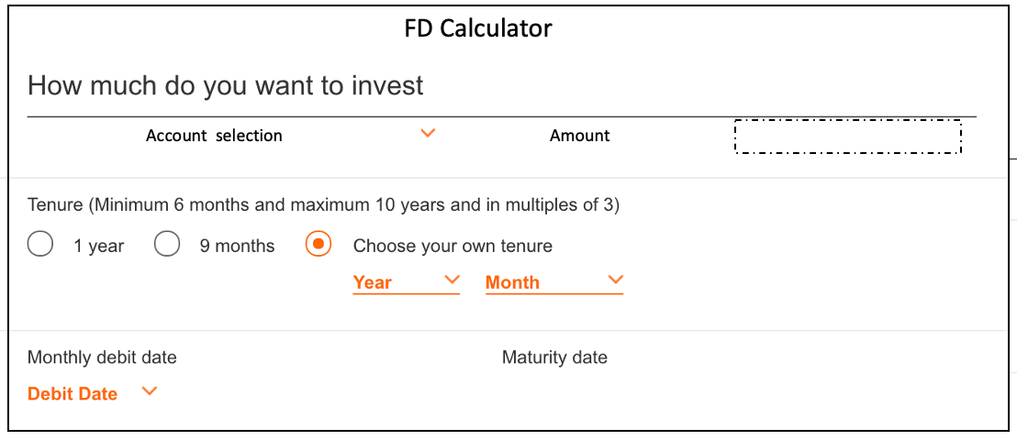

FD Creation

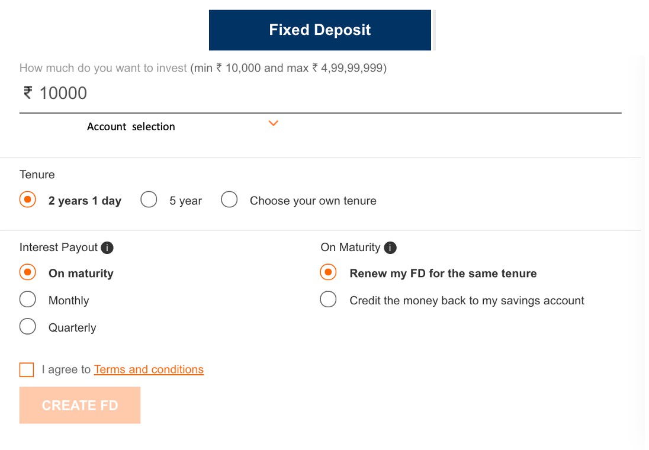

# Product Backlog in JIRA: (Screenshot from JIRA)

***Jira Board link: https://pckatrabad.atlassian.net/jira/software/c/projects/FD/boards/1/roadmap?selectedIssue=FD- 3&shared=&atlOrigin=eyJpIjoiNGU3NzIwZjNjYTg5NDEyNDg0NmMyZDgwZDIxNTM5YTciLCJwIjoiaiJ9dekh***

**Internet Banking**

|  |  |  |  |  |  |
| --- | --- | --- | --- | --- | --- |
| EPIC/S  tory ID | Title | Theme | Story Point | Acceptance Criteria | Iteration Path |
| FD-1/ FD-4 | As a customer of ABC bank I should be able to a create fixed deposit using my online banking account or existing mobile banking account so that I can invest my money in it | Internet Banking | 7 | Given that the user has access to the application. If the user is a valid customer of the bank and holds account with the bank and has internet banking there should provision to create a fixed deposit | Release 1-  Sprint 1 |
| FD-1/ FD-5 | As a customer of ABC bank I should be able to view the various FD rates based on period, amount to be invested and interest rates applicable for normal/senior citizen users so I can decide on the option | Internet Banking | 1 | The user should have provision to view the various Fixed deposit plans offered by the bank with following details   * Period (7 days to 10 years with appropriate intervals) * User rates (normal/senior) * Amount invested (Rates for amounts <1.5 Million USD or Rates for amounts >=1.5 Million to < 4 Million USD) | Release 1-  Sprint 1 |
| FD-1/ FD-6 | As a customer of ABC bank I should be able calculate the maturity amount using the fixed deposit calculator based on the investment amount entered and period selected so that I can visibility into the maturity amount | Internet Banking | 3 | The customer should be able to calculate the maturity amount based on the FD rates displayed on the website by provided the following the input   * Amount to be invested * Period of investment selected | Release 1-  Sprint 1 |
| FD-1/ FD-7 | As a customer of ABC bank I should be able to select a bank account from | Internet Banking | 3 | The customer who holds multiple bank accounts should be able choose from which account the money should be debited to create the fixed deposit | Release 1-  Sprint 1 |
|  | which the amount to be invested if I |  |  |  |
|  | hold multiple account at ABC bank so |  |  |  |
|  | that I can decide from which account |  |  |  |
|  | the money should be debited |  |  |  |

|  |  |  |  |  |  |
| --- | --- | --- | --- | --- | --- |
| FD-1/ FD-8 | As a customer of ABC bank I should be able to renew my fixed deposit for the same tenor as opted during the first time so that I can choose to reinvest the money | Internet Banking | 3 | The customer should have an option to renew the fixed at certain duration before maturity  The duration can set by the administrator | Release 1-  Sprint 1 |
| FD-1/ FD-9 | As a customer of ABC bank I should be able to choose where the maturity amount of the fixed deposit should be credited so I can choose between savings or current account | Internet Banking | 2 | The customer who holds multiple bank savings or current accounts should be able choose to which account the money should be credit once the fixed deposit is matured | Release 1-  Sprint 1 |
| FD-1/ FD-10 | As a customer of ABC bank I should be able to Joint FDs, so that I can associate the fixed deposit between two people | Internet Banking | 2 | The customer should be able to create joint FD with more than once customer of ABC bank, the system should validate the SSN details in this case | Release 1-  Sprint 1 |
| FD-1/ FD-11 | As a customer of ABC bank I should be able to choose a nominee for the fixed deposit so that the nominee is benefited with the fixed deposit in case of any unfortunate event | Internet Banking | 2 | The customer should be able to add nominee details to the FD at any point in time in duration of the FD with the following details  Name, Age & relationship with user | Release 1-  Sprint 1 |
|  |  |  |  | If the nominee is a minor, then system should request for the guardian details |  |
| FD-1/ FD-12 | As a customer of ABC bank I should receive a receipt of fixed deposit create in form of pdf copy on my registered email id with the bank so that I can maintain a record in case of any dispute. This email copy should be available on the internet & mobile banking platform as well | Internet Banking | 2 | The system should generate a receipt for the FD created with necessary details. This receipt should be a pdf file and   * Should be emailed to the customer * Should be available on the Internet & mobile banking platform | Release 1-  Sprint 1 |

**Mobile Banking**

|  |  |  |  |  |  |
| --- | --- | --- | --- | --- | --- |
| EPIC/S  tory ID | Title | Theme | Story Point | Acceptance Criteria | Iteration Path |
| FD-2/ FD-13 | As a customer of ABC bank I should be able to a create a fixed deposit using my online banking account or existing mobile banking account so that I can invest my money in it | Mobile Banking | 7 | Given that the user has access to the application. If the user is a valid customer of the bank and holds account with the bank and has Mobile banking there should be provision to create a fixed deposit | Release 1-  Sprint 2 |
| FD-2/ FD-14 | As a customer of ABC bank I should be able to view the various FD rates based on period, amount to be invested and interest rates applicable for normal/senior citizen users so I can decide on the option | Mobile Banking | 1 | The user should have provision to view the various Fixed deposit plans offered by the bank with following details   * Period (7 days to 10 years with appropriate intervals) * User rates (normal/senior) * Amount invested (Rates for amounts <1.5 Million USD or Rates for amounts >=1.5 Million to < 4 Million USD) | Release 1-  Sprint 2 |
| FD-2/ FD-15 | As a customer of ABC bank I should be able calculate the maturity amount using the fixed deposit calculator based on the investment amount entered and period selected so that I can visibility into the maturity amount | Mobile Banking | 3 | The customer should be able to calculate the maturity amount based on the FD rates displayed on the website by provided the following the input   * Amount to be invested * Period of investment selected | Release 1-  Sprint 2 |
| FD-2/ FD-16 | As a customer of ABC bank I should be able to select a bank account from | Mobile Banking | 3 | The customer who holds multiple bank accounts should be able choose from which account the money should be debited to create the fixed deposit | Release 1-  Sprint 2 |
|  | which the amount to be invested if I |  |  |  |
|  | hold multiple account at ABC bank so |  |  |  |
|  | that I can decide from which account |  |  |  |
|  | the money should be debited |  |  |  |
| FD-2/ FD-17 | As a customer of ABC bank I should be able to renew my fixed deposit for  the same tenor as opted during the | Mobile Banking | 3 | The customer should have an option to renew the fixed at certain duration before maturity | Release 1-  Sprint 2 |
|  | first time so that I can choose to |  |  |  |  |
|  | reinvest the money |  |  |  |  |

|  |  |  |  |  |  |
| --- | --- | --- | --- | --- | --- |
|  |  |  |  | The duration can set by the administrator |  |
| FD-2/ FD-18 | As a customer of ABC bank I should be able to choose where the maturity | Mobile Banking | 2 | The customer who holds multiple bank savings or current accounts should be able choose to which account the money should be credit once the fixed deposit is matured | Release 1-  Sprint 2 |
|  | amount of the fixed deposit should be |  |  |  |
|  | credited so I can choose between |  |  |  |
|  | savings or current account |  |  |  |
| FD-2/ FD-19 | As a customer of ABC bank I should be able to Joint FDs, so that I can associate the fixed deposit between two people | Mobile Banking | 2 | The customer should be able to create joint FD with more than once customer of ABC bank, the system should validate the SSN details in this case | Release 1-  Sprint 2 |
| FD-2/ FD-20 | As a customer of ABC bank I should be able to choose a nominee for the fixed deposit so that the nominee is benefited with the fixed deposit in case of any unfortunate event | Mobile Banking | 2 | The customer should be able to add nominee details to the FD at any point in time in duration of the FD with the following details  Name, Age & relationship with user | Release 1-  Sprint 2 |
|  |  |  |  | If the nominee is a minor, then system should request for the guardian details |  |
| FD-2/ FD-21 | As a customer of ABC bank I should receive a receipt of fixed deposit create in form of pdf copy on my registered email id with the bank so that I can maintain a record in case of any dispute. This email copy should be available on the internet & mobile banking platform as well | Mobile Banking | 2 | The system should generate a receipt for the FD created with necessary details. This receipt should be a pdf file and   * Should be emailed to the customer * Should be available on the Internet & mobile banking platform | Release 1-  Sprint 2 |

**Reports**

|  |  |  |  |  |  |
| --- | --- | --- | --- | --- | --- |
| EPIC/S  tory ID | Title | Theme | Story Point | Acceptance Criteria | Iteration Path |
| FD-3/ | As an employee of the bank I should | Mobile | 5 per | The employee of the ABC bank | Release 1- |
| FD-22 | be able to view the following reports | Banking | report | should be able to generate the | Sprint 3 |
|  | with the necessary details so they |  |  | report and view them |  |
|  | make better decisions based on the |  |  |  |  |
|  | same |  |  |  |  |

|  |  |  |  |  |  |
| --- | --- | --- | --- | --- | --- |
|  | * Total value of FDs for users with tenor of less than 6 months. * Total value of FDs for senior citizens with tenor of less than 6 months. * Total value of FDs for users with tenor of between 6 months 1 day and 1 year. * Total value of FDs for senior citizens with tenor of between 6 months 1 day and 1 year. * Number of FDs that are more than   1.5 million USD for normal users.   * Number of FDs that are more than   1.5 million USD for senior citizen users. |  |  |  |  |
| FD-3/ FD-23 | As an employee of the bank I should be able to export the desired report in excel format so that I can further analyse the data | Mobile Banking | 1 per report | The employee of the ABC bank should able download the reports in excel format at click of the button | Release 1-  Sprint 3 |

JIRA Board Screen shot

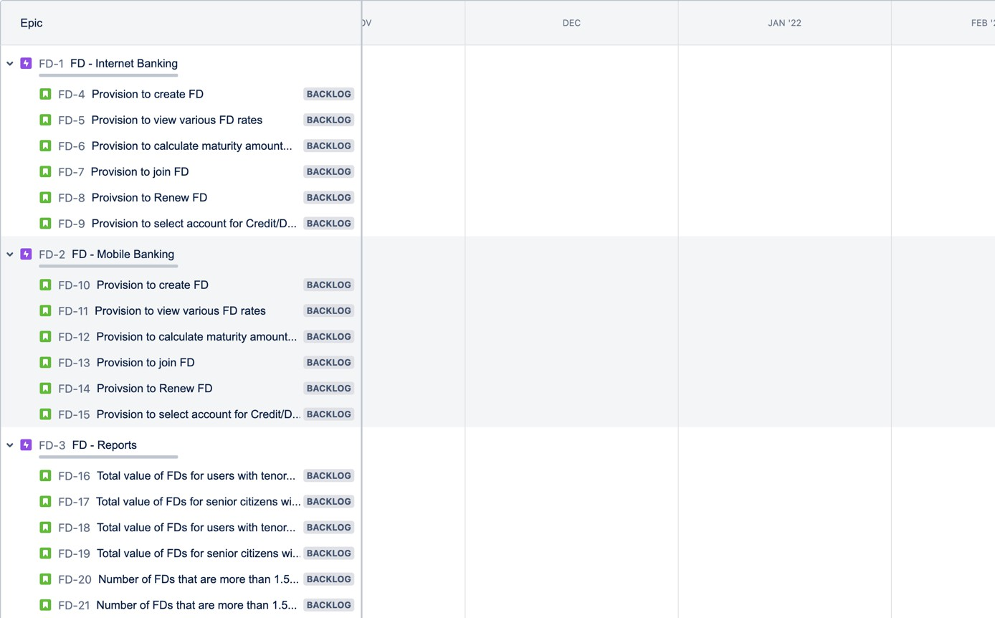

JIRA EPIC Sample

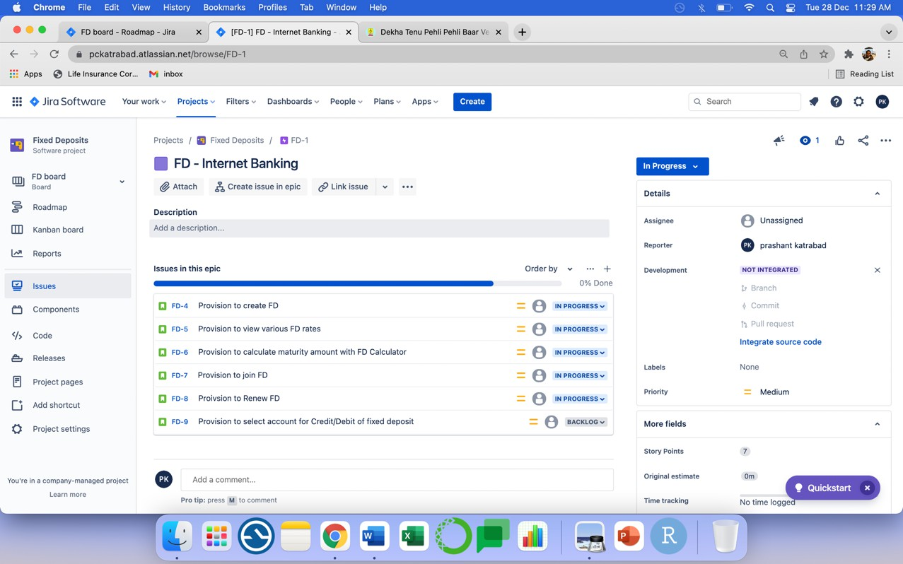

JIRA Sample user story

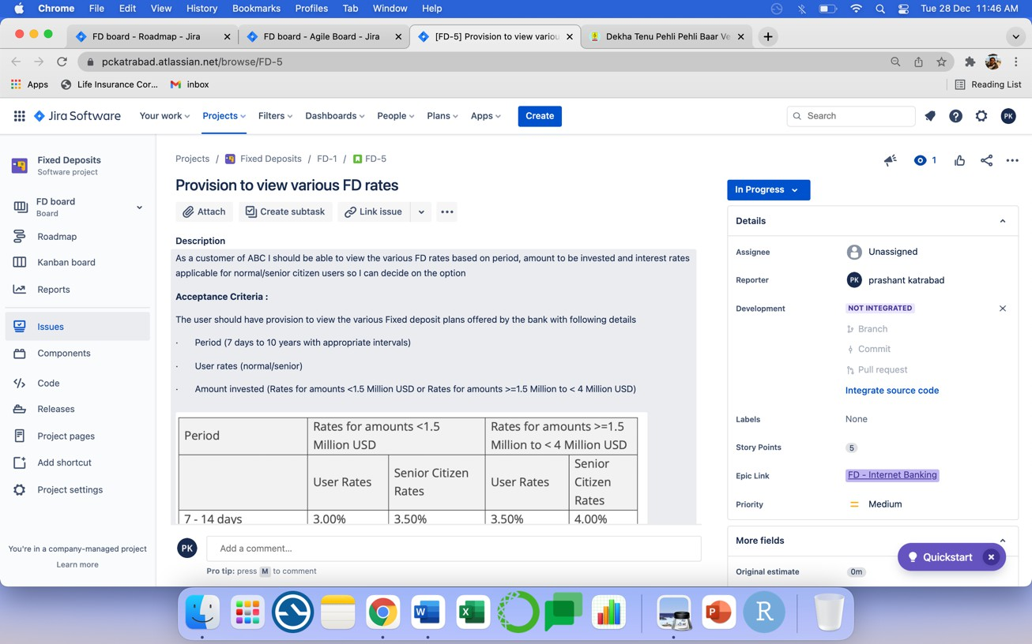

# Excel Tasks

1. Create a bar graph showing the FD sales investment. Draw two bar graphs: one for normal users and other for senior citizens. label the chart drawn correctly so that senior management gets a clear report of sales.
2. Arrange the data above in excel in an ascending and descending order.
   1. Using vlookup for product code HDH, find the rate for senior citizens for amounts less than 2 crore
   2. Using vlookup for product code YFF, find the rate for senior citizens for amounts less than 2 crore.

|  |  |  |  |  |  |  |
| --- | --- | --- | --- | --- | --- | --- |
|  |  |  |  |  |  |  |
| Q1 | Using vlookup for product code HDH, find the rate for senior citizens for amounts less than 2 crore. | | | | | |
| **Ans** | **3.5** | **%** |  |  |  |  |
|  | **=VLOOKUP(C4,C4:G12,4,TRUE)*100** |  |  |  |  |  |
|  |  |  |  |  |  |  |
| Q2 | Using vlookup for product code YFF, find the rate for senior citizens for amounts less than 2 crore. | | | | | |
| **Ans** | **6.25** | **%** |  |  |  |  |
|  | **=VLOOKUP(C12,C4:G12,3,TRUE)*100** |  |  |  |  |  |

# Tableau Tasks

Create a dashboard for senior management to view FDs created over the last 6 months. Make assumptions as appropriate and create the dashboard using your own mock data. For any missing data, make your assumptions to create mock data. Write down the assumptions as well.

